<https://appmetrica.yandex.com/application/new>

Demand point

1. Attribution platform access: pb parameter docking

2. Attribution platform identification

3. Attribution Platform Verification

4. Network alliance support

Event callback settings

1. Check to return all events
2. Each attribution link can add up to 5 postbacks

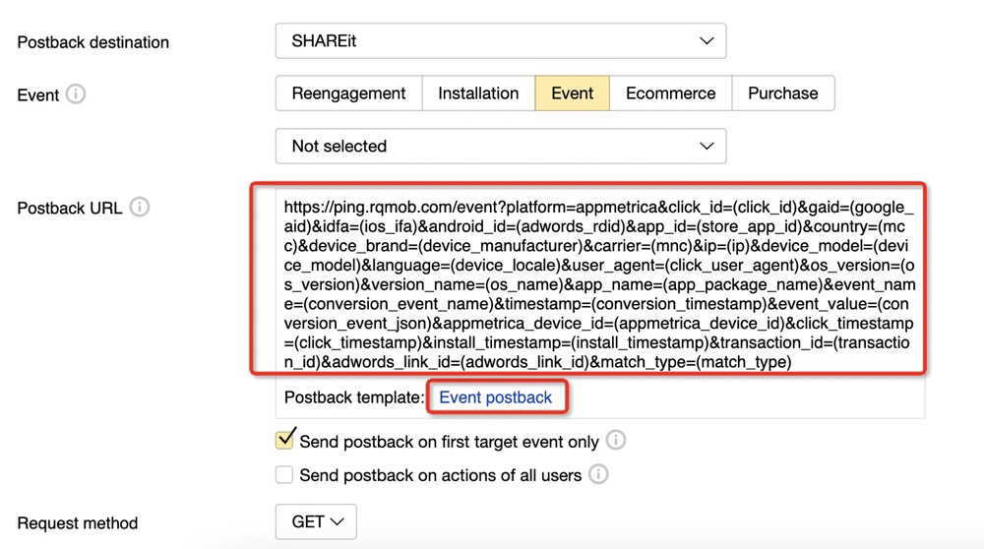

1. reengagement

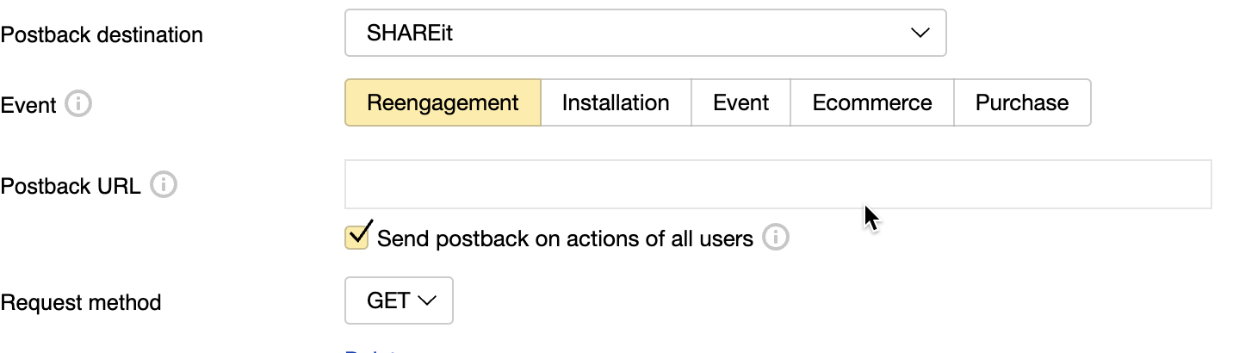

1. install

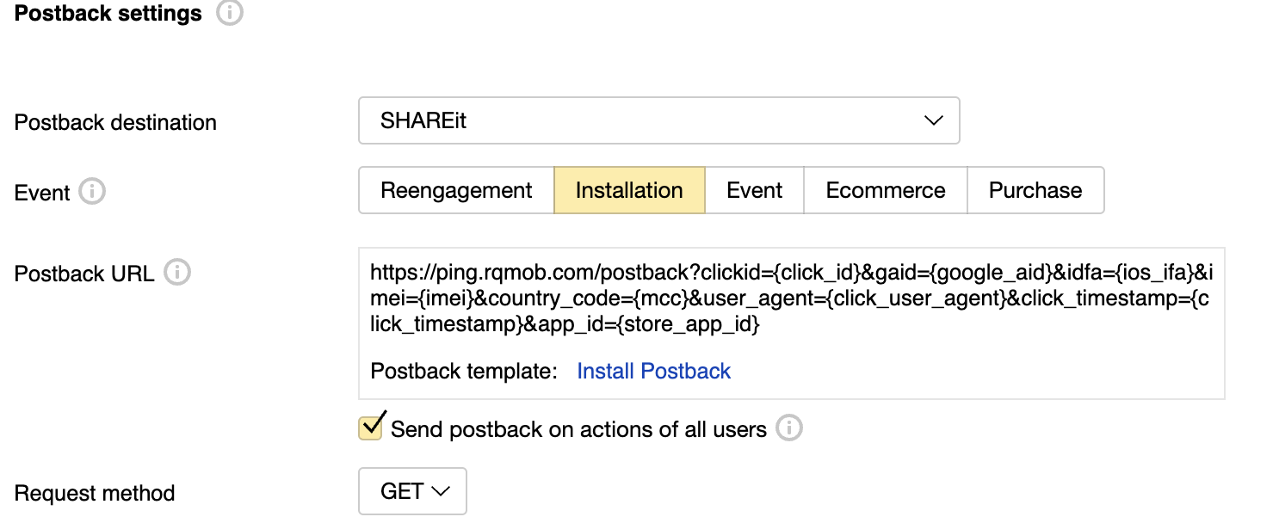

1. event
   1. event, e-commerce、purchase event

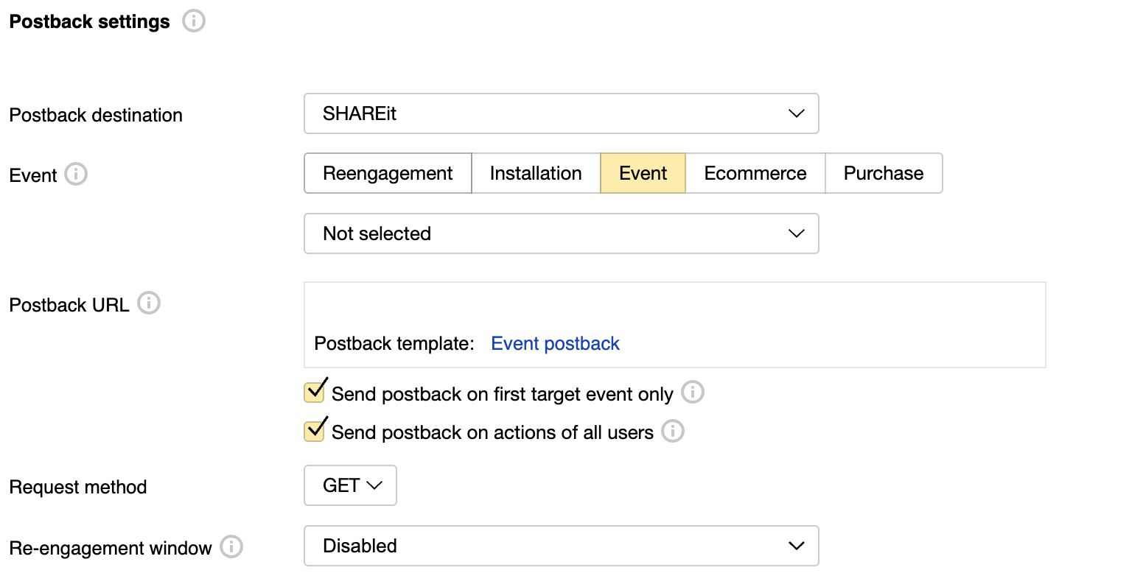

Configure pb url

1. Method 1: Fill in the pb url directly when creating the attribution link

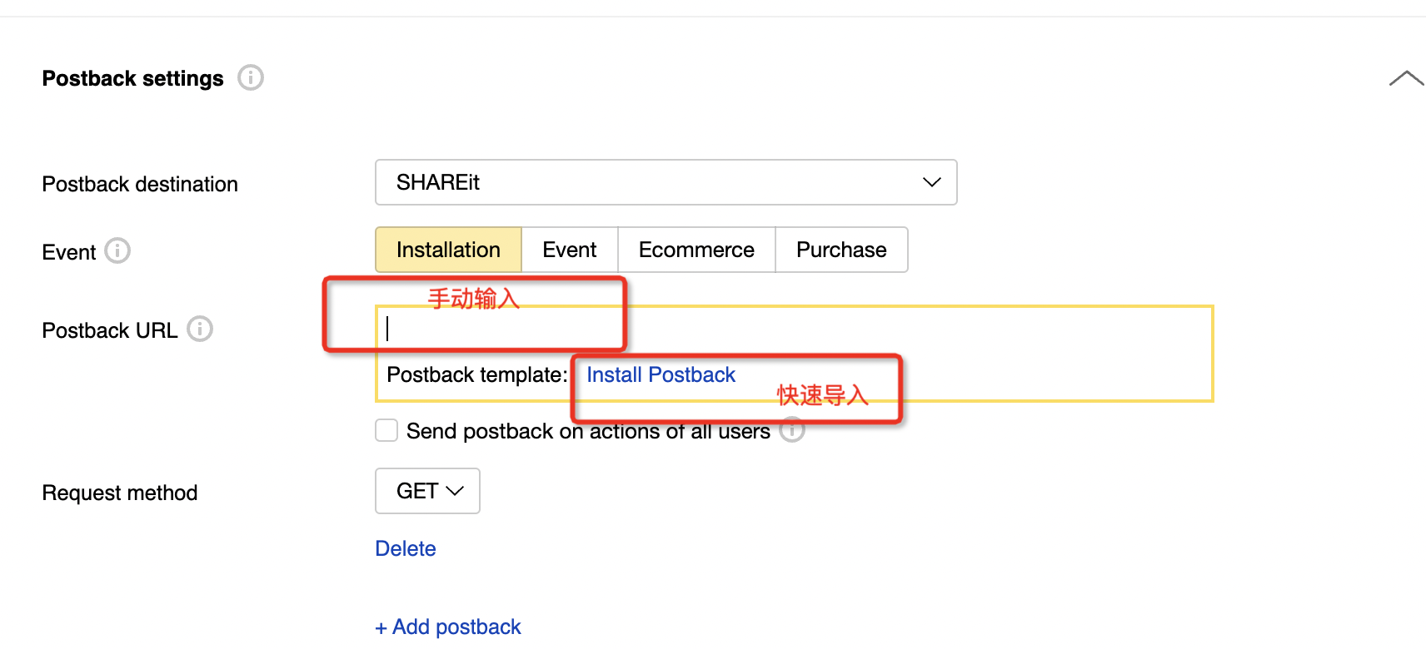

1. 2. Method 2: After the advertiser sets the shareit channel as the default pb, the corresponding pb url can be quickly imported when creating an attribution link

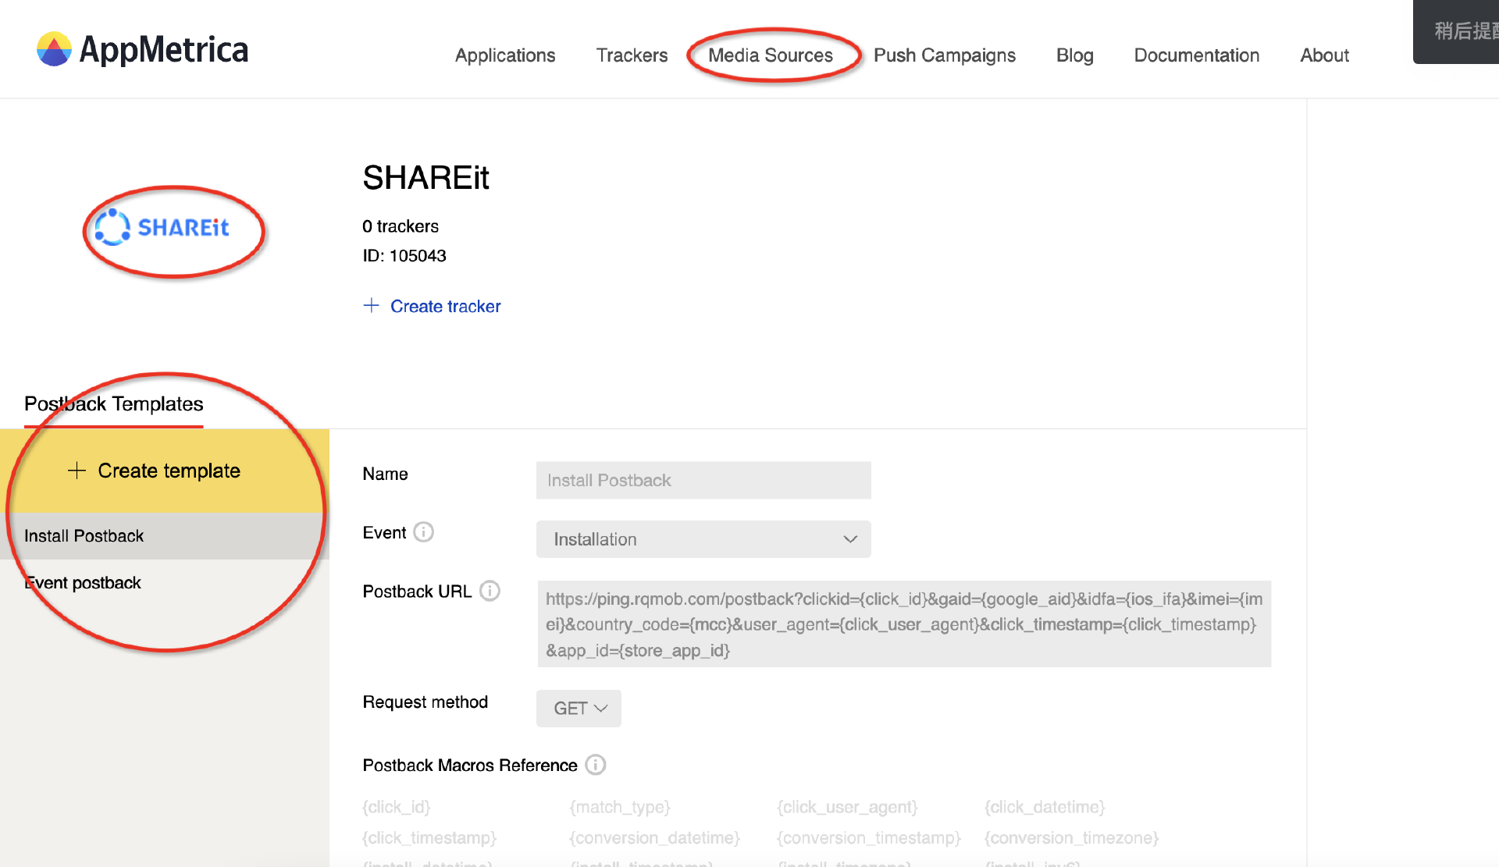

Return type

● Emails about application installations (installation emails).

● Postbacks about specified events that occur in the application after installation (event postbacks).

● Postbacks when e-commerce events are received from the application (e-commerce postbacks).

● A postback when an event about an in-app purchase (purchase postback) is received from the app

rule

● When the specified event or installation property occurs, a postback is sent. There was a delay of about 5 minutes in sending.

● When HTTP status 200 OK is received, it is considered sent successfully.

● If a different HTTP status is received, AppMetrica will resend the postback within the next 24 hours. The resend is repeated every 5-10 minutes.

● An event postback is sent for events that occur within 6 months of installation.

|  |  |  |
| --- | --- | --- |
| language on device | Attribution Platform Macros | Description |
| Information about clicks, installs and events | {adwords_link_id} | ID for Google Ads and AppMetrica links |
|  | {click_id} | Unique click ID. This macro does not apply to unattributed postbacks. |
|  | {transaction_id} | Occurrence ID of the event or installation. For example, if the same device generates the same event, the transaction_id changes. |
|  | {click_timestamp} | Click time in Unix timestamp format in seconds. |
|  | {conversion_timestamp} | is the conversion time (event on the device) in Unix timestamp format in seconds |
|  | {conversion_event_name} | The event name for the registered transition |
|  | {conversion_event_json} | Nested event attributes in JSON format |
|  | {install_timestamp} | is the installation time in Unix timestamp format in seconds |
| 设备信息 | {google_aid} | is the device's Google AID format received from the device |
|  | {device_manufacturer} | Device manufacturers (such as Apple or Samsung) detected by the AppMetrica service |
|  | {device_model} | The device model detected by the AppMetrica service (e.g. Galaxy S6) |
|  | {device_locale} | is the language on the device |
|  | {os_version} | is the version of the operating system on the user's device |
|  | {mcc} | Mobile country code. |
| 有关应用程序和操作系统的信息 | {app_version_name} | is the app version in the format specified by the developer |
|  | {app_package_name} | is the package name for Android or the Bundle ID for iOS (for example, ru.yandex.metro) |

install pb url

https://ping.rqmob.com/postback?clickid={click_id}&gaid={google_aid}&app_id={app_id}&country_code={country_iso_code}&install_unix_ts={install_timestamp}&click_ts={click_timestamp}&transaction_id={transaction_id}&device_manufacturer={device_manufacturer}&device_model={device_model}&language={device_locale}&os_version={os_version}&app_version_name={app_version_name}&app_name={app_package_name}&adwords_link_id={adwords_link_id}&platform=appmetrica

reengagement pb url

https://ping.rqmob.com/postback?clickid={click_id}&gaid={google_aid}&app_id={app_id}&country_code={country_iso_code}&install_unix_ts={install_timestamp}&click_ts={click_timestamp}&transaction_id={transaction_id}&device_manufacturer={device_manufacturer}&device_model={device_model}&language={device_locale}&os_version={os_version}&app_version_name={app_version_name}&app_name={app_package_name}&adwords_link_id={adwords_link_id}&is_retargeting=1&retargeting_conversion_type=reengagement&platform=appmetrica

event pb url

https://ping.rqmob.com/event?click_id={click_id}&gaid={google_aid}&app_id={app_id}&country={country_iso_code}&event_name={conversion_event_name}&timestamp={conversion_timestamp}&event_value={conversion_event_json}&click_ts={click_timestamp}&transaction_id={transaction_id}&device_manufacturer={device_manufacturer}&device_model={device_model}&language={device_locale}&os_version={os_version}&app_version_name={app_version_name}&app_name={app_package_name}&adwords_link_id={adwords_link_id}&platform=appmetrica

* **Click on the attribution link** Documentation https://yandex.com/dev/appmetrica/doc/mobile-tracking/concepts/tracking-specification.html
* Important macro parameter description:

|  |  |  |  |
| --- | --- | --- | --- |
| Attribution Platform Macros | Is it required? | Description |  |
| click_id={click_id} | yes | Macro for transmitting a unique click ID. Used for deduplication. |  |
| google_aid={gaid} | recommend |  |  |
| afpub_id={YOURMACRO} |  | Partner ID |  |
| custom_parameter=value |  | manual macro |  |

|  |  |  |  |
| --- | --- | --- | --- |
| s2s attribution link parameters | Is it required? | Description |  |
| device_ip={ip} | Yes | The URL-encoded IP address of the device. Support IPv4 and IPv6 |  |
| device_ua={uagent} | Yes | The URL-encoded user-agent of the device |  |
| click_timestamp={timestamp} | Yes | The UTC timestamp of the hit in seconds |  |
| noredirect=1 | No | Notifies AppMetrica that the click should be counted without redirecting to the app store. The default value is 1 |  |

**Attribution Link Example** Android (human understanding, non-real attribution link, this is an attribution link that supports s2s)https://redirect.appmetrica.yandex.com/serve/600573419754384676?click_id={click_id}&google_aid={gaid}&device_ip={ip}&device_ua={uagent}&click_timestamp={timestamp}&noredirect=1

Note: The attribution link provided by the advertiser needs to contain the required macros in the above 2 tables. Otherwise s2s will be unsuccessful

where TRACKING_ID is the ID of the tracker in AppMetrica (present in the user's tracking URL).

AppMetrica's HTTP response code for this request: 204 No Content.

**midas side attribution platform identification license**

**platform name**

**Appmetrica**

**platform icon**

**Youmin Wang-Youmin Wang**

**domain name recognition**

* redirect.appmetrica.yandex.com
* appmetrika.yandex.com
* appmetrica.yandex.ru
* appmetrika.yandex.ru

Attribution Link Check

|  |  |
| --- | --- |
| Attribution Platform Macros | Required? |
| click_id={clickid} | Yes |
| google_aid={gaid} | Yes |

1. **Additional instructions for attribution platforms**
   1. Install attribution 1 time, other judgments are natural amount

AppMetrica attributes the install of an application to a partner only once, if it is installed on the same device. All the subsequent installs of the app are registered as organic.

* + 1. <https://yandex.com/dev/appmetrica/doc/mobile-tracking/concepts/testing-attribution.html#test>

Attribution testing method<https://yandex.com/dev/appmetrica/doc/mobile-tracking/concepts/testing-attribution.html#test>

2. 【Important‼ ️】Please pay attention to the configuration order of the return url. After verification, it is found that when configuring pburl, the advertiser should configure the installation first, and then configure the event. Otherwise, the clickid may not be recycled, resulting in superset not seeing the installation number

Error case: